**VISVESVARAYA TECHNOLOGICAL UNIVERSITY**

"Jnana Sangama", Belagavi-590 018



A Mini -Project Work on

**“Online examination management System”**

A Dissertation work submitted in partial fulfillment of the requirement

for the award of the degree

**Bachelor of Engineering**

In

**Computer Science & Engineering**

Submitted by

**ARGHYA PATRA 1AY20CS020**

**AGASTYA NAND 1AY20CS009**

Under the guidance of

**Ms.Sujatha T**

**Ms. Rakshitha**

Assistant Professor



**DEPARTMENT OF COMPUTER SCIENCE & ENGINEERING**

**ACHARYA INSTITUTE OF TECHNOLOGY**

**(AFFILIATED TO VISVESVARAYA TECHNOLOGICAL UNIVERSITY, BELAGAVI.APPROVED BY AICTE, NEW DELHI, ACCREDITED BY NAAC, NEW DELHI )**

Acharya Dr. Sarvepalli Radhakrishnan Road, Soldevanahalli, Bengaluru-560107

**2022-23**

**DEPARTMENT OF COMPUTER SCIENCE & ENGINEERING**

ACHARYA INSTITUTE OF TECHNOLOGY

**(AFFILIATED TO VISVESVARAYA TECHNOLOGICAL UNIVERSITY, BELAGAVI.APPROVED BY AICTE, NEW DELHI, ACCREDITED BY NAAC, NEW DELHI)**

Acharya Dr. Sarvepalli Radhakrishnan Road, Soldevanahalli, Bengaluru-560107



**Certificate**

This is to certify that the Mini-Project work entitled **“ONLINE EXAMINATION MANAGEMENT SYSTEM”** is a bonafide work carried out by **ARGHYA PATRA (1AY20CS020) and AGASTYA NAND (1AY20CS009)**  in partial fulfillment for the award of the degree of **Bachelor of Engineering** in **Computer Science and Engineering** of the **Visvesvaraya Technological University**, Belagavi during the year 2022-23. It is certified that all corrections/suggestions indicated for Internal Assessment have been incorporated in the Report deposited in the departmental library. The Project has been approved as it satisfies the academic requirements in respect of Project work prescribed for the Bachelor of Engineering Degree.

**Ms.Sujatha T & Ms. Rakshitha Prof. Ajith Padyana**

Guide HOD

**Name of the Examiners Signature with date**



**ACKNOWLEDGEMENT**

The satisfaction that accompanies the successful completion of this mini-project would be incomplete without the mention of the people who made it possible through constant guidance and encouragement.

We would take this opportunity to express our heart-felt gratitude to **Sri. B. Premnath Reddy**, Chairman, Acharya Institutes and **Dr.Rajath Hegde M M**, Principal, Acharya Institute of Technology for providing the necessary infrastructure to complete this mini-project.

We wish to express our deepest gratitude and thanks to **Prof. Ajith Padyana**, Head of the Department, Computer Science and Engineering.

We wish to express sincere thanks to my guide **Ms. Sujatha T & Ms. Rakshitha** , Assistant Professor, Department of Computer Science and Engineering for helping us throughout and guiding us from time to time.

A warm thanks to all the faculty of Department of Computer Science and Engineering, who have helped us with their views and encouraging ideas.

**ABSTRACT**

Online Examination  Management System is a web-based examination system where examinations are given online. either through the internet or intranet using computer system. The main goal of this online examination system is to effectively evaluate the student thoroughly through a totally automated system that not only reduce the required time but also obtain fast and accurate results.

It is an online test simulator is to take online examination, test in an efficient manner and no time wasting for manually checking of the test paper. The main objective of this web based online examination system is to efficiently evaluate the student thoroughly through a fully automated system that not only saves lot of time but also gives fast and accurate results. For students they give papers according to their convenience from any location by using internet and time and there is no need of using extra thing like paper, pen etc.

**TABLE OF CONTENTS**

**Acknowledgement i**

**Abstract ii  
1. Introduction 1**1.1 Introduction to DBMS 1  
 1.1.1 Why DBMS? 2  
 1.1.2 Database applications 2  
 1.1.3 Advantages of DBMS 3  
 1.1.4 Components of DBMS 4  
 1.1.5 Three-Schema architecture 5

**2. System Requirements 6**2.1 Hardware Requirements 6  
2.2 Software Requirements 6

**3. Design 7**3.1 ER Diagram 7  
3.2 Schema Diagram 8

**4. Implementation 9**4.1 Tables 9  
 4.1.1 student 9  
 4.1.2 staff 9  
 4.1.3 dept 10  
 4.1.4 quiz 10  
 4.1.5 score 11  
 4.1.6 questions 11

4.1.7 contact 12

4.2 Triggers 13

4.3 Stored Procedure 14

**5. Snapshots 15  
Conclusion & Future Enhancements 23**  
**Bibliography 24**

**TABLE OF FIGURES**

1.1 Components of Database Management System 4

1.2 Architecture of database system 5

3.1 Entity Relationship Diagram 7

3.2 Schema Diagram 8

**SNAPSHOTS:**

5.1 Snapshot of home screen 16

5.2 Snapshot of login 17

5.3 Snapshot of Signup page for Staff/Student 18

5.4 Snapshot of Dashboard page/stored procedure 19

5.5 Snapshot of Examination view of Student 20

5.6 Snapshot of profile view of Student 20

5.7 Snapshot of stored trigger (ON DELETE Quiz)21

**CHAPTER 1**

**INTRODUCTION**

Online Examination Management System is a web-based examination system where examinations are given online. either through the internet or intranet using computer system. The main goal of this online examination system is to effectively evaluate the student thoroughly through a totally automated system that not only reduce the required time but also obtain fast and accurate results.

It is an online test simulator is to take online examination, test in an efficient manner and no time wasting for manually checking of the test paper. The main objective of this web based online examination system is to efficiently evaluate the student thoroughly through a fully automated system that not only saves lot of time but also gives fast and accurate results. For students they give papers according to their convenience from any location by using internet and time and there is no need of using extra thing like paper, pen etc.

This system fulfills the requirements of the University to conduct exams online. They just have to register on the site and enter the details of the students who can appear in the exam. Students can give exam without the need of going to any physical destination. They can view the results at the same time. Thus, the purpose of the site is to provide a system that saves the efforts and time of both the University and the students.

* 1. **Introduction to DBMS**

DBMS stands for **D**ata**b**ase **M**anagement **S**ystem. We can break it like this DBMS = Database + Management System. Database is a collection of data and Management System is a set of programs to store and retrieve those data. Basically DBMS is a software tool to organize (create, retrieve, update and manage) data in a database.

The main aim of a DBMS is to supply a way to store up and retrieve database information that is both convenient and efficient. By data, we mean known facts that can be recorded and that have embedded meaning. Normally people use software such as DBASE IV or V, Microsoft ACCESS, or EXCEL to store data in the form of database. A datum is a unit of data. Meaningful data combined to form information. Hence, information is interpreted data – data provided with semantics. MS. ACCESS is one of the most common examples of database management software.

Database systems are meant to handle large collection of information. Management of data involves both defining structures for storage of information and providing mechanisms that can do the manipulation of those stored information. Moreover, the database system must ensure the safety of the information stored, despite system crashes or attempts at unauthorized access.

* + 1. **Why DBMS?**
* To develop software applications in less time.
* Data Independence and efficient use of data.
* For uniform data administration.
* For data integrity and security.
* For concurrent access of data, and data recovery from crashes.
* To use user-friendly declarative query language.
  + 1. **Database applications**
* **Telecom:** There is a database to keeps track of the information regarding calls made, network usage, customer details etc. Without the database systems it is hard to maintain that huge amount of data that keeps updating every millisecond.
* **Industry:** Where it is a manufacturing unit, warehouse or distribution centre, each one needs a database to keep the records of ins and outs. For example distribution centre should keep a track of the product units that supplied into the centre as well as the products that got delivered out from the distribution centre on each day; this is where DBMS comes into picture.
* **Education sector:** Database systems are frequently used in schools and colleges to store and retrieve the data regarding student details, staff details, course details, exam details, payroll data, attendance details, fees details etc. There is a hell lot amount of inter-related data that needs to be stored and retrieved in an efficient manner.
* **Online shopping:** You must be aware of the online shopping websites such as Amazon, Flipkart etc. These sites store the product information, your addresses and preferences, credit details and provide you the relevant list of products based on your query. All this involves a Database management system.
* **Banking system:** For storing customer info, tracking day to day credit and debit transactions, generating bank statements etc. All this work has been done with the help of Database management systems.
  + 1. **Advantages of DBMS**

A DBMS manage data and has many advantages.

* **Data Independence:** Application programs should be as free or independent as possible from details of data representation and storage. DBMS can supply an abstract view of the data for insulating application code from such facts.
* **Efficient data access:** DBMS utilizes a mixture of sophisticated concepts and techniques for storing and retrieving data competently and this feature becomes important in cases where the data is stored on external storage devices.
* **Data integrity and security:**  If data is accessed through the DBMS, the DBMS can enforce integrity constraints on the data.
* **Data administration:** When several users share the data, integrating the administration of data can offer major improvements. Experienced professionals understand the nature of the data being managed and can be responsible for organizing the data representation to reduce redundancy and make the data to retrieve efficiently.
* **Providing backup and recovery:** A DBMS must provide facilities for recovering from hardware or software failures. The backup and recovery subsystem of the DBMS is responsible for recovery.
* **Permitting inferencing and actions using rules:** Some database systems provide capabilities for defining deduction rules for inferencing new information from the stored database facts.
  + 1. **Components of DBMS**

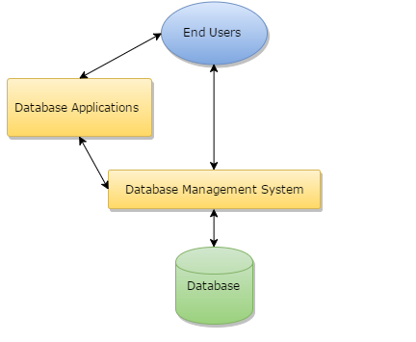

**Fig-1.1: Components of a Database Management System**

* **Users:** Users may be of any kind such as DB administrator, System developer or database users.
* **Database application:** Database application may be Departmental, Personal, organization’s and / or Internal.
* **DBMS:** Software that allow users to create and manipulate database access.
* **Database:** Collection of logical data as a single unit.
* **Database access language:** This is used to access the data to and from the database, to enter new data, update existing data, or retrieve required data from databases. The user writes a set of appropriate commands in a database access language, submits these to the DBMS, which then processes the data and generates and displays a set of results into a user readable form.
  + 1. **Three-Schema architecture**

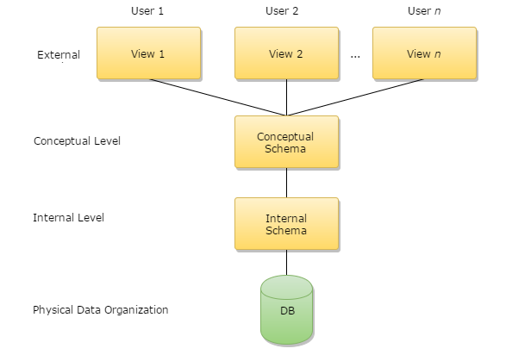

**Fig-1.2: Architecture of database system**

The levels form a three-level architecture that includes an external, a conceptual, and an internal level. The way users recognize the data is called the external level. The way the DBMS and the operating system distinguish the data is the internal level, where the data is actually stored using the data structures and file. The conceptual level offers both the mapping and the desired independence between the external and internal levels.

**CHAPTER 2**

**SYSTEM REQUIREMENTS**

**2.1 Hardware Requirements**

* **Processor:** Intel Core2 Quad @ 2.4Ghz on Windows® Vista 64-Bit / Windows® 7 64-Bit / Windows® 8 64-Bit / Windows® 8.1 64-Bit.
* **RAM:** 1GB of RAM
* **Memory:** 128GB Hard drive
* **Keyboard:** MS compatible keyboard
* **Mouse:** MS compatible mouse

**2.2 Software Requirements**

* **Operating system:** Windows® Vista 64-Bit / Windows® 7 64-Bit / Windows® 8 64-Bit / Windows® 8.1 64-Bit,Windows 10(All versions)
* **Front end:** HTML ,CSS,BOOTSTRAP, JAVASCRIPT
* **Back end:** MYSQL database
* **Programming Language:** PHP
* **Software:** Visual Studio, Xampp server.

**CHAPTER 3**

**DESIGN**

**3.1 ER Diagram**

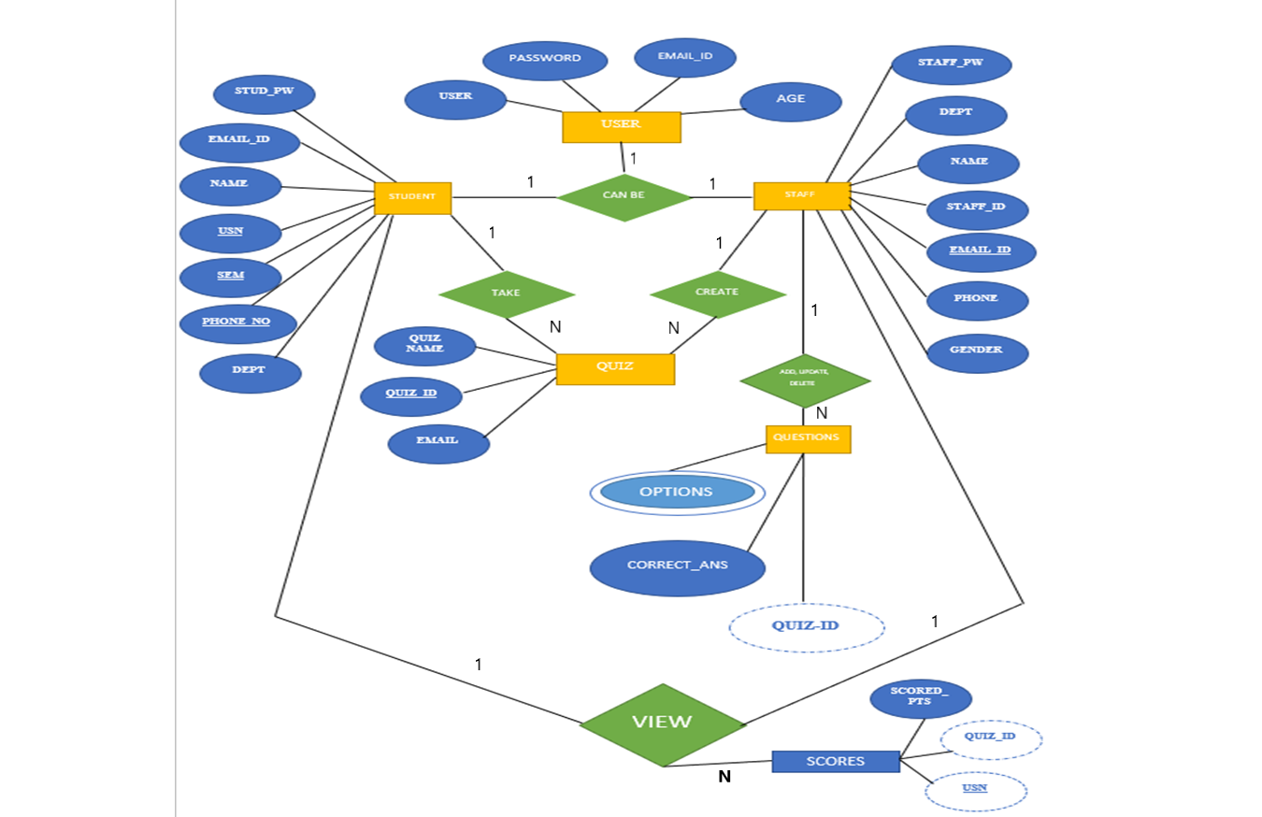

**Fig-3.1: Entity Relationship Diagram**

* User Can be Student(1:1)
* User Can be Staff(1:1)
* Staff creates Quizzes(1:N)
* Student takes Quizzes(1:N)
* Staff add,update,delete Questions(1:N)
* Students view Score(1:N)
* Staff view Score(1:N)

**3.2 Schema Diagram**

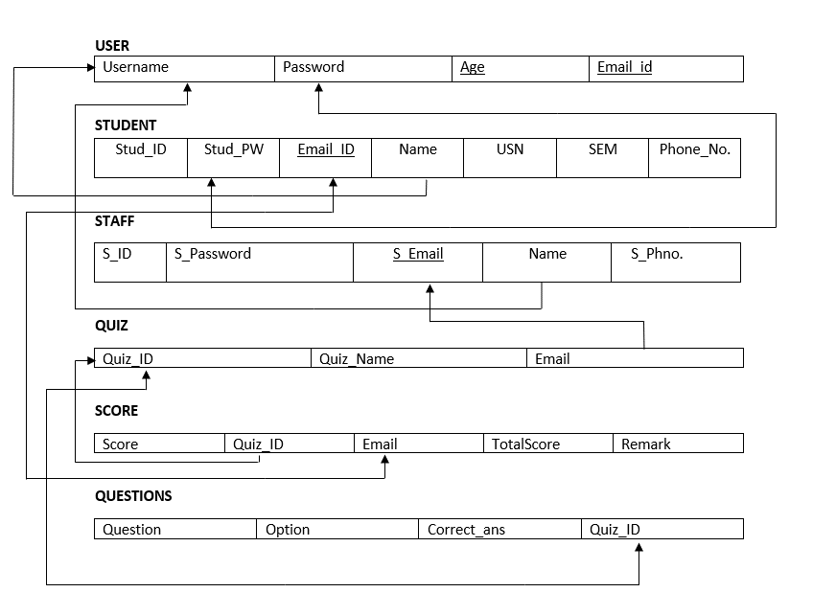

**Fig-3.2: Schema Diagram**

**Schema Diagram:** An illustrative display of (most aspects of) a database schema.

**Schema Construct:** A component of the schema or an object within the schema,

e.g., STUDENT,STAFF.

**CHAPTER 4**

**IMPLEMENTATION**

**4.1 Tables**

**4.1.1 Student_login**

|  |  |  |  |
| --- | --- | --- | --- |
| **SNO** | **COLUMN_NAME** | **DATA_TYPE** | **DESCRIPTION** |
| 1 | student_id | Integer | Primary Key |
| 2 | name | Varchar |  |
| 3 | mail | Varchar | Foreign key references user |
| 4 | Ph-no | Varchar |  |
| 5 | gender | Varchar |  |
| 6 | DOB | Varchar |  |
| 7 | pw | Varchar |  |
| 8 | dept | Varchar |  |

CREATE TABLE `student` (

`usn` varchar(10) NOT NULL,

`name` varchar(20) NOT NULL,

`mail` varchar(30) NOT NULL,

`phno` varchar(10) NOT NULL,

`gender` varchar(1) NOT NULL,

`DOB` varchar(10) NOT NULL,

`pw` varchar(200) NOT NULL,

`dept` varchar(3) DEFAULT NULL

);

**4.1.2 Staff**

|  |  |  |  |
| --- | --- | --- | --- |
| **SNO** | **COLUMN_NAME** | **DATA_TYPE** | **DESCRIPTION** |
| 1 | staffid | integer | Primary Key |
| 2 | name | varchar | Foreign key references user |
| 3 | mail | varchar |  |
| 4 | phno | varchar |  |
| 5 | gender | varchar |  |
| 6 | DOB | varchar |  |
| 7 | pw | varchar |  |
| 8 | dept | varchar |  |

CREATE TABLE `staff` (

`staffid` varchar(10) NOT NULL,

`name` varchar(20) NOT NULL,

`mail` varchar(30) NOT NULL,

`phno` varchar(10) NOT NULL,

`gender` varchar(1) NOT NULL,

`DOB` varchar(10) NOT NULL,

`pw` varchar(200) NOT NULL,

`dept` varchar(3) DEFAULT NULL

);

**4.1.3 Questions**

|  |  |  |  |
| --- | --- | --- | --- |
| **SNO** | **COLUMN_NAME** | **DATA_TYPE** | **DESCRIPTION** |
| 1 | QUIZ_ID | INT | Primary Key |
| 2 | OPTION1 | Varchar |  |
| 3 | OPTION2 | Varchar |  |
| 4 | OPTION3 | Varchar |  |
| 5 | ANSWER | Varchar |  |
| 6 | QS | Varchar |  |

CREATE TABLE `questions` (

`qs` varchar(200) NOT NULL,

`op1` varchar(30) NOT NULL,

`op2` varchar(30) NOT NULL,

`op3` varchar(30) NOT NULL,

`answer` varchar(30) NOT NULL,

`quizid` int(11) NOT NULL

);

**4.1.4 QUIZ**

|  |  |  |  |
| --- | --- | --- | --- |
| **SNO** | **COLUMN_NAME** | **DATA_TYPE** | **DESCRIPTION** |
| 1 | `quizid` | Integer | Primary Key |
| 2 | `quizname` | VARCHAR |  |
| 3 | `date_created` | VARCHAR |  |
| 4 | `mail` | VARCHAR |  |

CREATE TABLE `quiz` (

`quizid` int(11) NOT NULL,

`quizname` varchar(20) NOT NULL,

`date_created` timestamp NOT NULL DEFAULT current_timestamp(),

`mail` varchar(30) DEFAULT NULL

);

**4.1.5 SCORE**

|  |  |  |  |
| --- | --- | --- | --- |
| **SNO** | **COLUMN_NAME** | **DATA_TYPE** | **DESCRIPTION** |
| 1 | slno | Integer | Primary key |
| 2 | score | Integer |  |
| 3 | quizid | Integer |  |
| 4 | mail | varchar |  |
| 5 | totalscore | Integer |  |
| 6 | `remark` | Varchar |  |

CREATE TABLE `score` (

`slno` int(11) NOT NULL,

`score` int(11) NOT NULL,

`quizid` int(11) NOT NULL,

`mail` varchar(30) DEFAULT NULL,

`totalscore` int(11) DEFAULT NULL,

`remark` varchar(20) DEFAULT NULL

);

**4.1.7 WEB_FORM**

|  |  |  |  |
| --- | --- | --- | --- |
| **SNO** | **COLUMN_NAME** | **DATA_TYPE** | **DESCRIPTION** |
| 1 | id | Integer | Primary key |
| 2 | Cat_name | Varchar2 |  |
| 3 | Cat_desc | Varchar2 |  |

CREATE TABLE `web_form` (

`id` int(11) NOT NULL,

`name` varchar(150) NOT NULL,

`email` varchar(150) NOT NULL,

`msg` text NOT NULL

);

**4.2 Triggers**

**1)CREATE TRIGGER `ondeleteqs` AFTER DELETE ON `quiz`**

**FOR EACH ROW delete from questions where questions.quizid=old.quizid**

**2)** **CREATE TRIGGER `remarks` BEFORE INSERT ON `score`**

**FOR EACH ROW set NEW.remark = if(NEW.score = 0, 'bad', 'good')**

**3)** **CREATE TRIGGER `ondeletecon` AFTER DELETE ON `web_form`**

**FOR EACH ROW INSERT INTO contact_log SET id=OLD.id,name= OLD.name,email = OLD.email,msg = OLD.msg**

**4.3 Stored Procedures**

**CREATE DEFINER=`root`@`localhost` PROCEDURE `leaderboard`()**

**NO SQL**

**select q.quizname,s.score,s.totalscore,st.name,s.mail from score s,student st,quiz q where s.mail=st.mail and q.quizid=s.quizid order by score DESC**

**CHAPTER 5**

**SNAPSHOTS**

The snapshot contains the welcome screen of the online examination management  
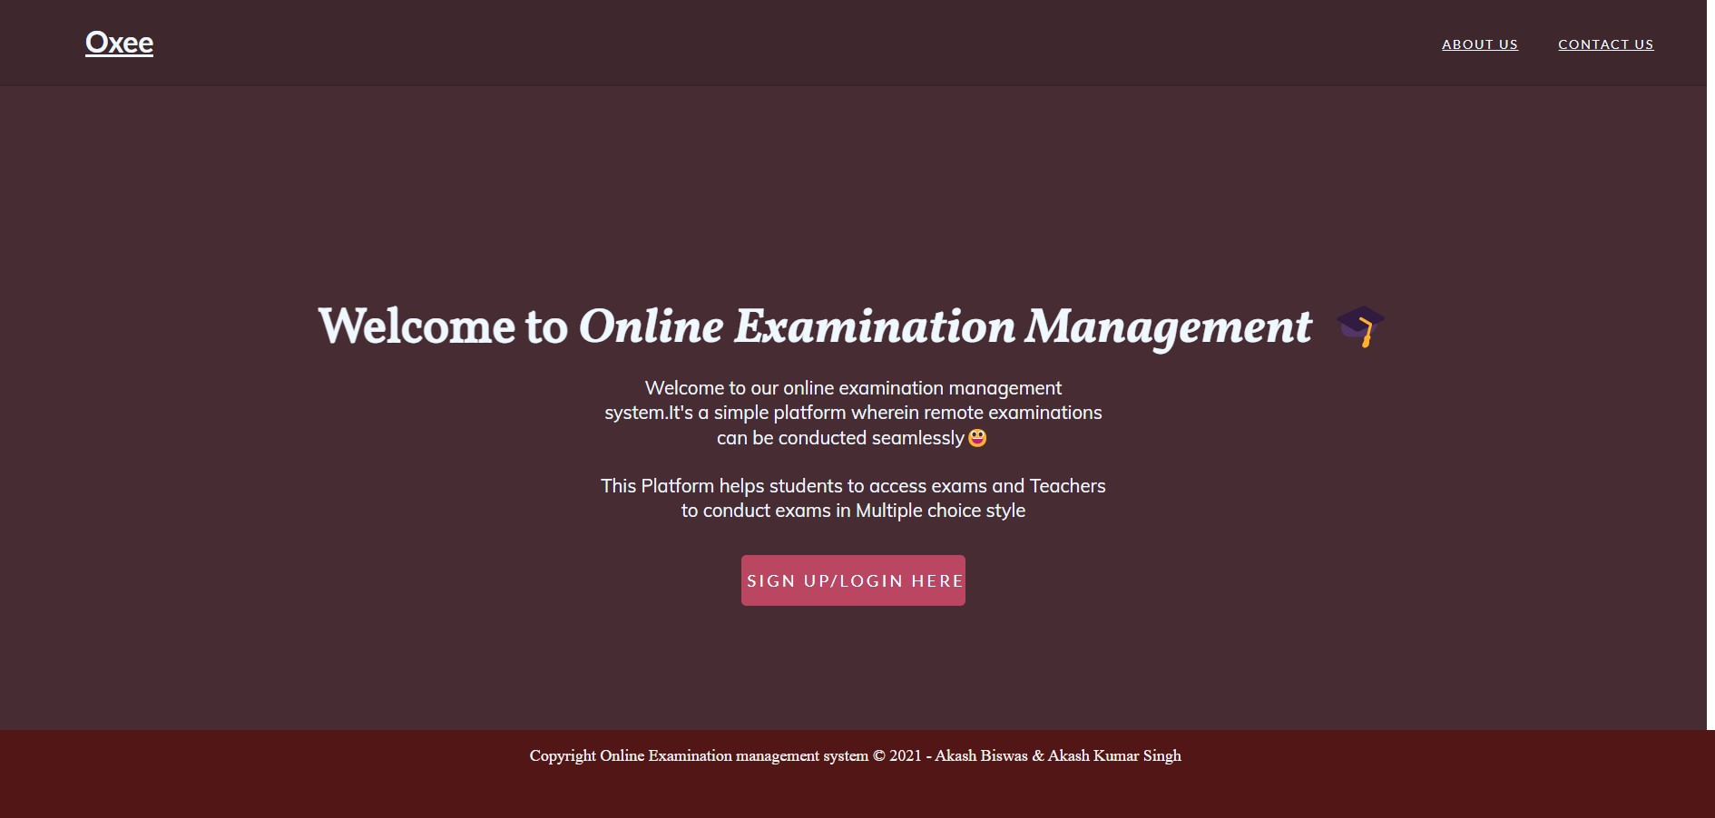

**Fig-5.1: Start page of the project**

**The following snapshot contains details about the LOGIN**

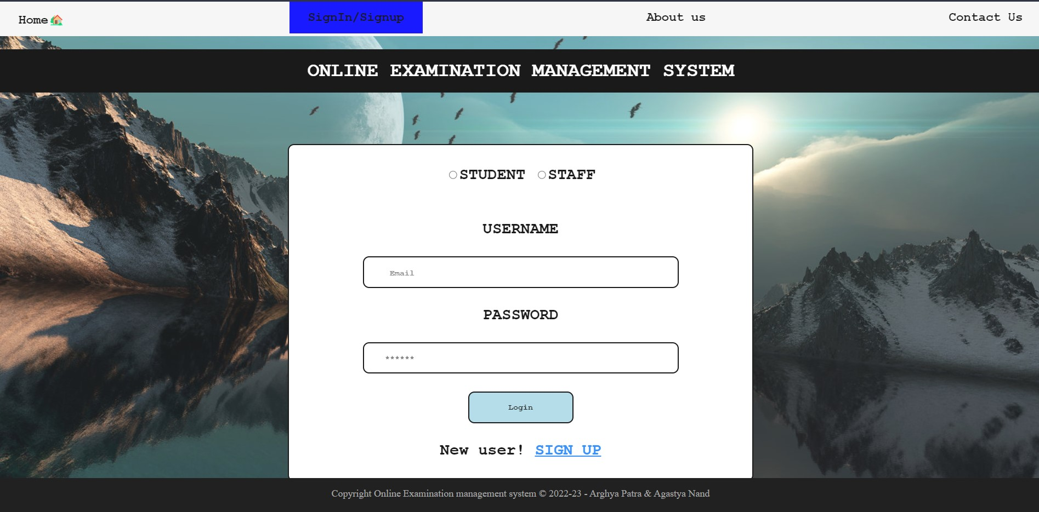

**Fig-5.2: Snapshot of login page/sign-up page**

**This snapshot contains contact details of Signup for Student/Staff**

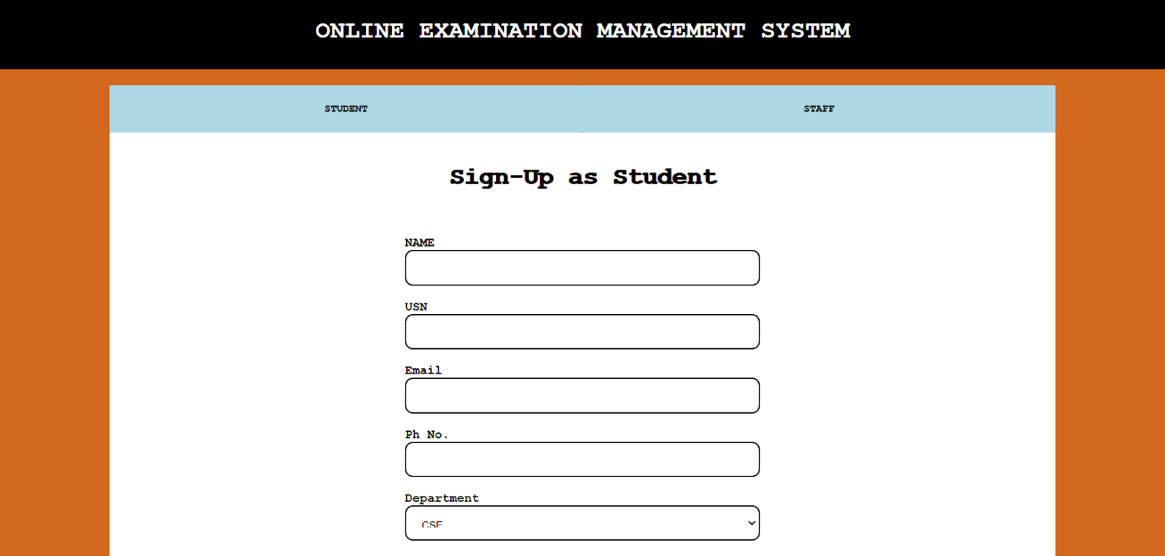

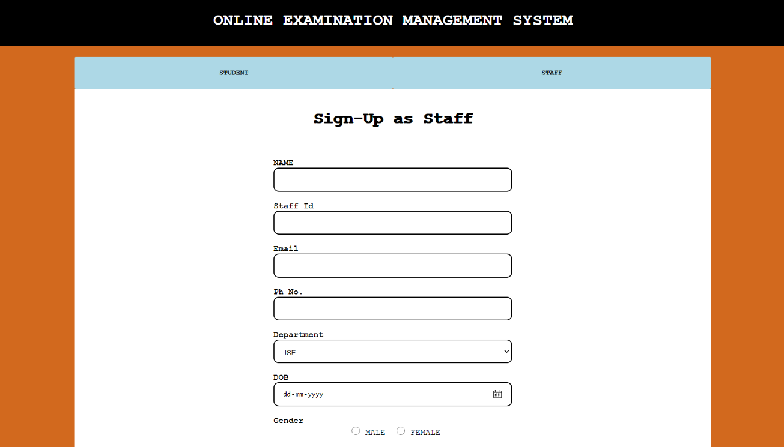

**Fig-5.3: Snapshot of Signup page for student/staff**

The following snapshot is the sign-up page of the job portal where user can fill in all required details if he/she is visiting the portal for first time.

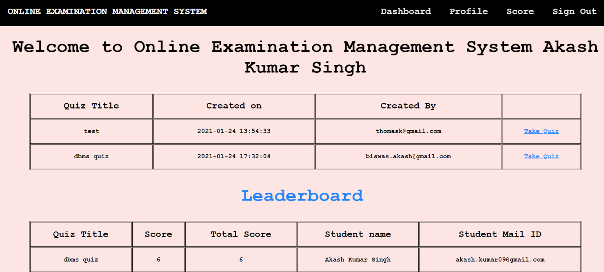

**A Snapshot of the stored procedure for leaderboard**

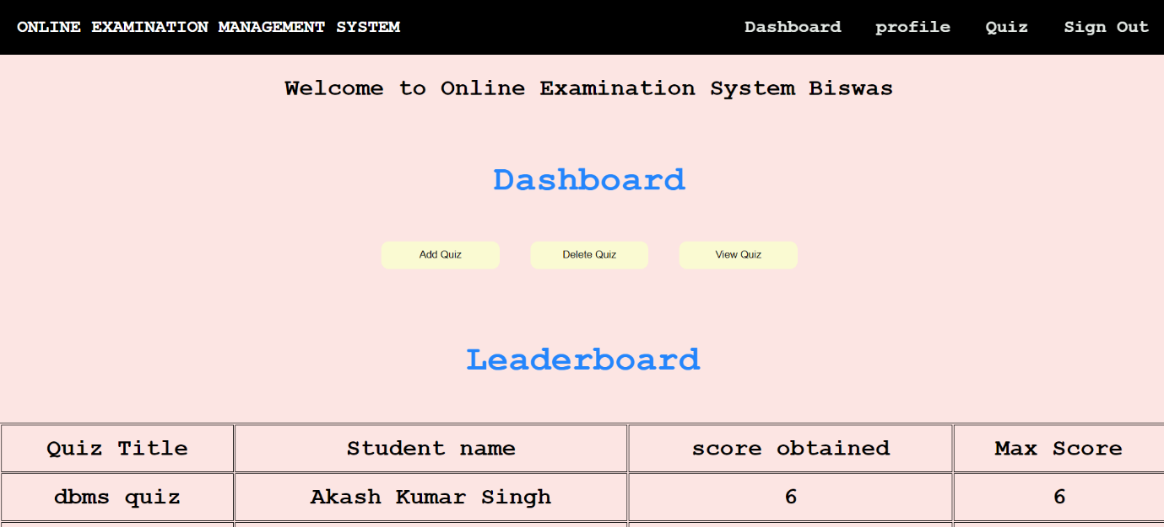

**(Staff View)**

**Fig-5.4: Snapshot of Dashboard page of Student/Staff**

The following snapshot is the dashboard page for the users who already have an account of their own.

**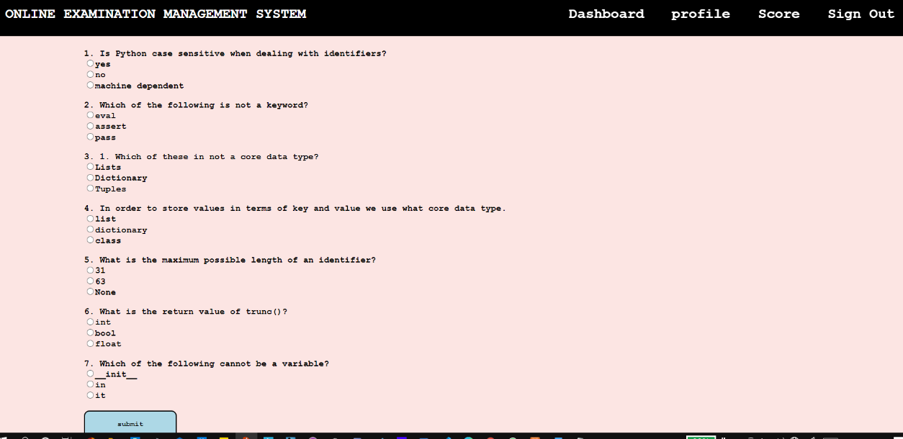  
Fig-5.5: Examination view of student**

The following snapshot is the Examination view of the student of take Quiz view of the student.

**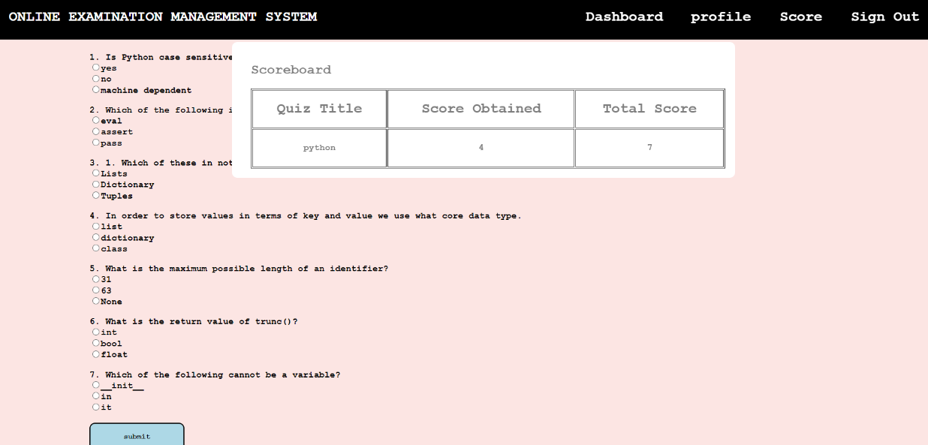  
 Fig-5.6: Profile view of Student**

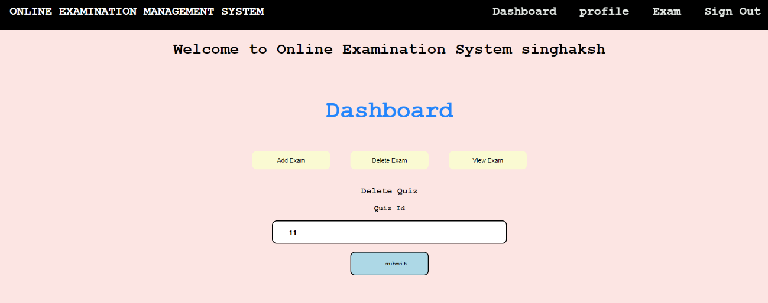

**Fig-5.7: Snapshot of stored Trigger(On Delete Quiz)**

This snapshot contains the trigger function of on Delete quiz where the quiz id gets updated on deleting a quiz

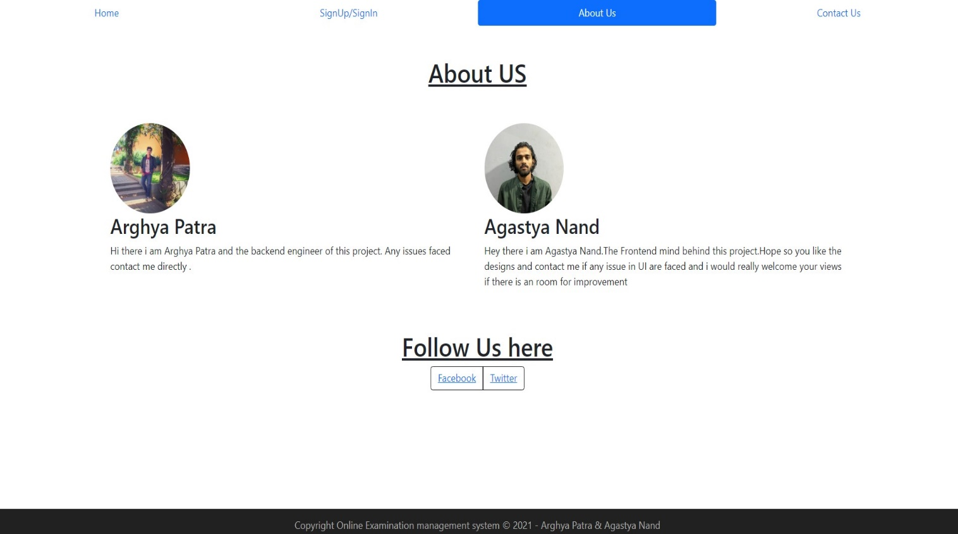

**Fig-5.8: Snapshot of the About US page**

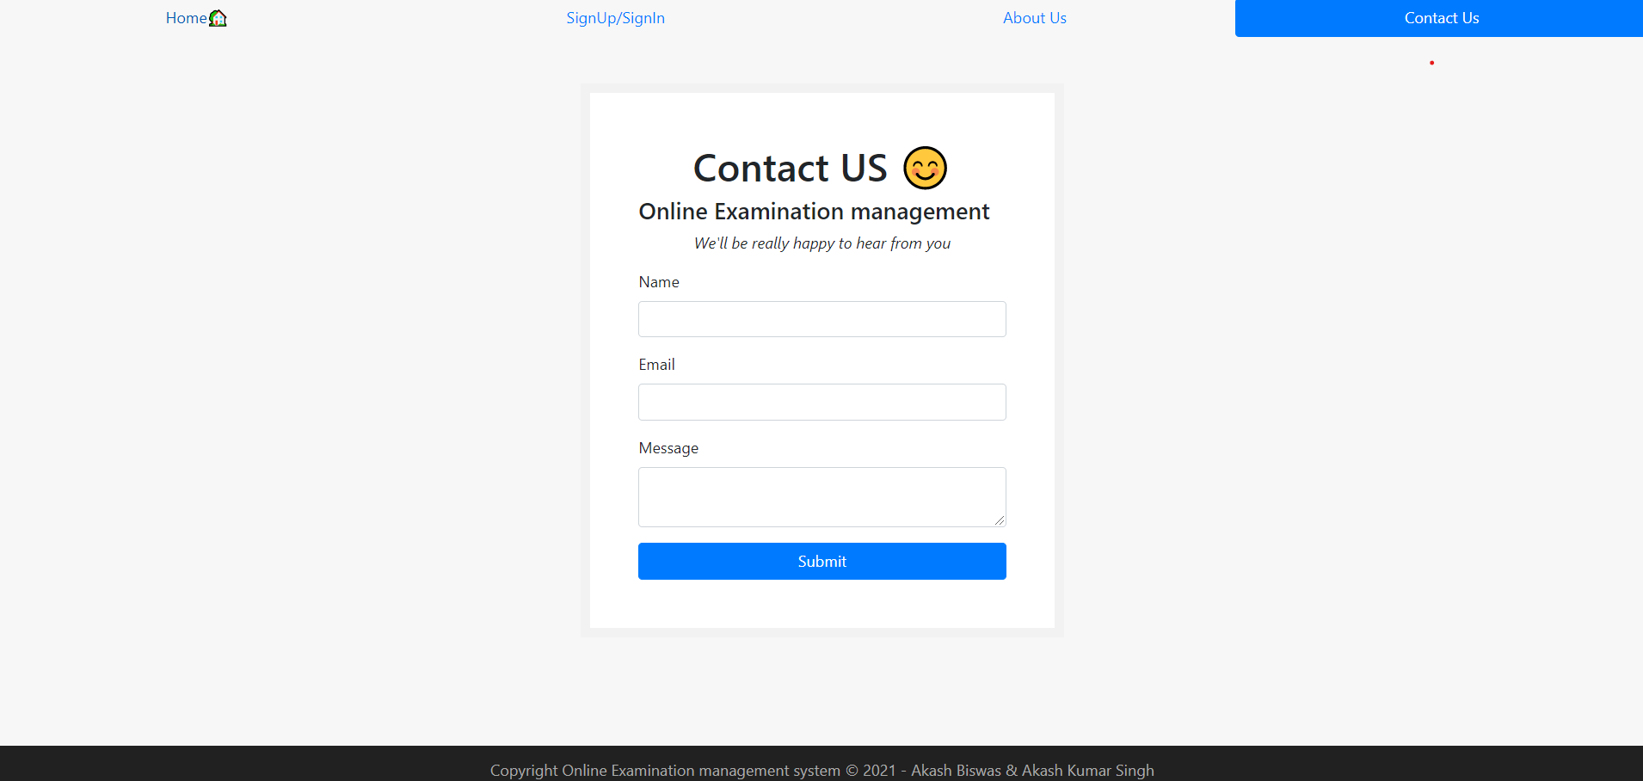

**Fig-5.9: Snapshot of Contact page**

**CONCLUSION & FUTURE ENHANCEMENT**

The online examination system provides better functionality for an examination to be more efficient and reduce manual paperwork in order to automate all possible tasks. For implementing this system, PHP, HTML, CSS, JavaScript and MySql are used.

The system comprises of following features:

* Management of quiz.
* Automated grading.
* Adding/deleting quizzes and questions.

**SCOPE OF ENHANCEMENT**

There are also few features which can be integrated with the system to make it more flexible.

Below list shows the future points to be considered:

* Implementing the timer for the quiz.
* Sending mails on sign up and when student takes the quiz.
* Supporting all type of questions including MCQ’s.
* Allowing webcam monitoring during exam
* Prevent user to change tabs during an exam
* Forgot password functionality to allow users who have forgotten password

**BIBLIOGRAPHY**

**Web References**

1. <https://www.w3schools.in/dbms/intro/>

Introduction to DBMS

2. <https://beginnersbook.com/2015/04/dbms-introduction/>

Introduction to DBMS

3. [www.oracle.com/technetwork/database/enterprise-edition/documentation/database 093888.html](http://www.oracle.com/technetwork/database/enterprise-edition/documentation/database%20093888.html)

Oracle database documentation

4. [www.oracle.com/technetwork/developer-tools/sql-developer/documentation/index.html](http://www.oracle.com/technetwork/developer-tools/sql-developer/documentation/index.html)

SQL Developer documentation

5. <https://docs.oracle.com/cd/B28359_01/appdev.111/b28843/tdddg_procedures.htm>

Procedures documentation

6. <https://docs.oracle.com/javase/8/docs/technotes/guides/jdbc/>

JDBC documentation

**Book References**

1. Fundamentals of Database Systems, RamezElmasri and Shamkant B. Navathe, 7th Edition,

2017, Pearson

2. Herbert Schildt, Java The Complete Reference, 7th Edition, Tata McGraw Hill, 2007